SWE20001 – Development Project 1: Tools and Practices

Pass Task <3>

Duy Phuong Nguyen (101204984)

Lab: Friday 2:30pm

Tutor: Huai Liu

Team number: 3

Henry Tran 102075482

Edward Knight 102700043

Duy Phuong Nguyen 101204984

Christian Ilott 102169762

This report summarises my contributions to the teamwork in Week <3> as well as the tasks I have performed during this week:

**Week 3: Submission details and assessment criteria**

1. As the team leader of group 3 this week. I create a project on GitHub and invited all our group members: Henry and Edward.

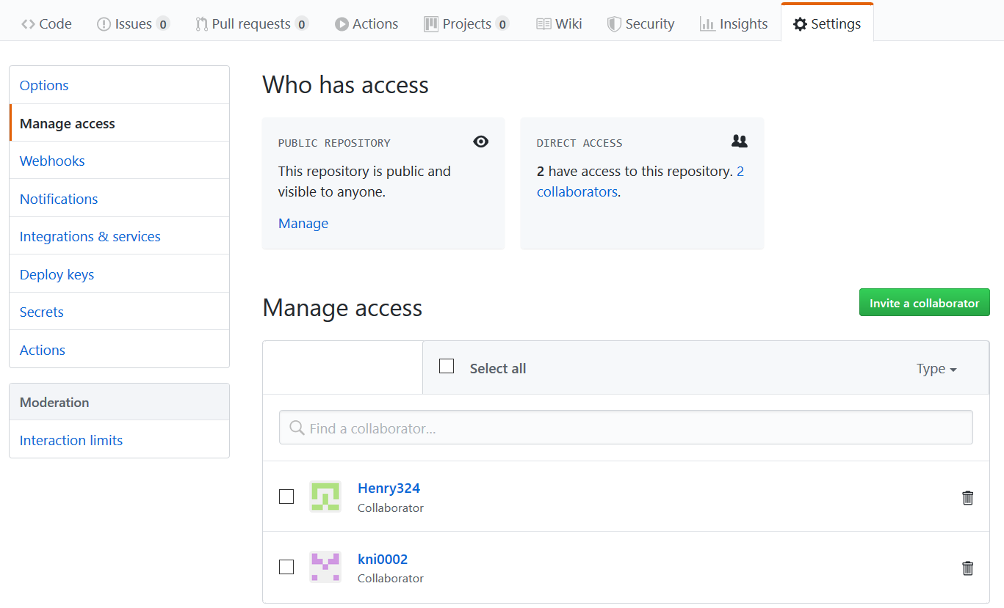

1. I created new pages using “Add a custom slidebar” method on the GitHub. There are 6 required pages: Team and Title details, Overview of the gameplay, Game Screen and Flow, User Interface, Assets

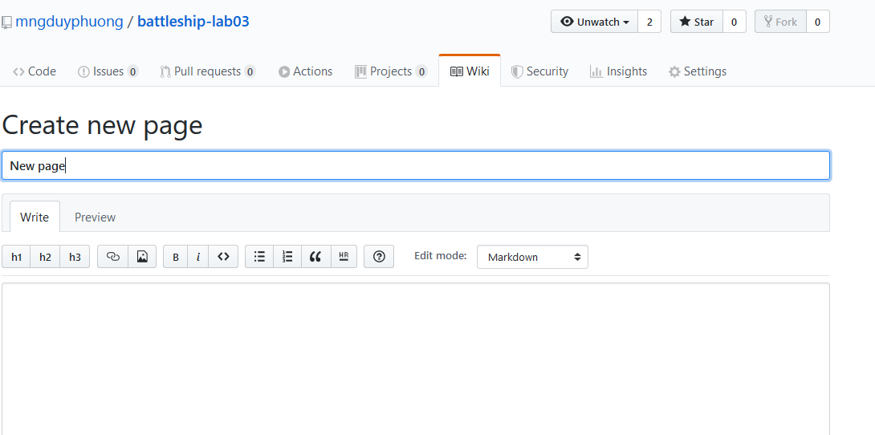

1. Homepage and required pages are created

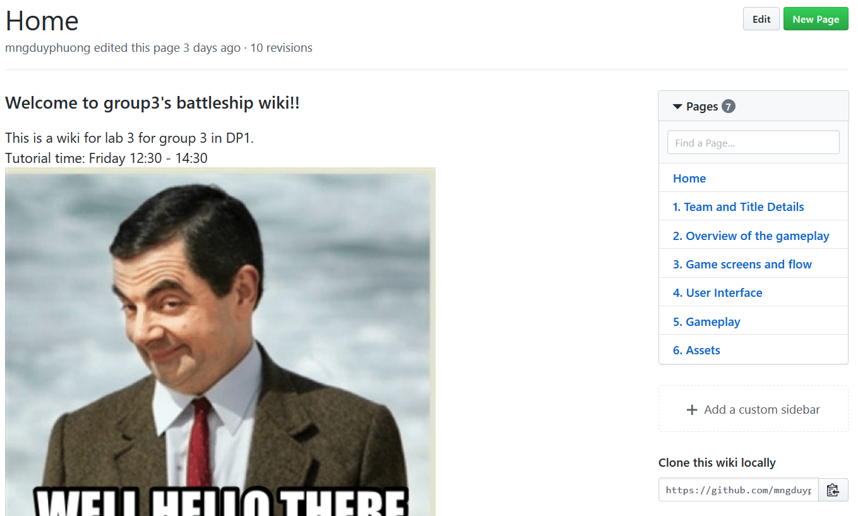

1. One of our team members is not coming this week so as the leader, I decided the task of this week is divided between 3 members: Duy Phuong, Henry, Edward.

* Duy Phuong: team leader, part 1 and part 4.
* Henry: part 2, part 5 and part 6.
* Edward: he has the hardest part which is part 5 “Game screens and flow”. This one requires some designing skills.

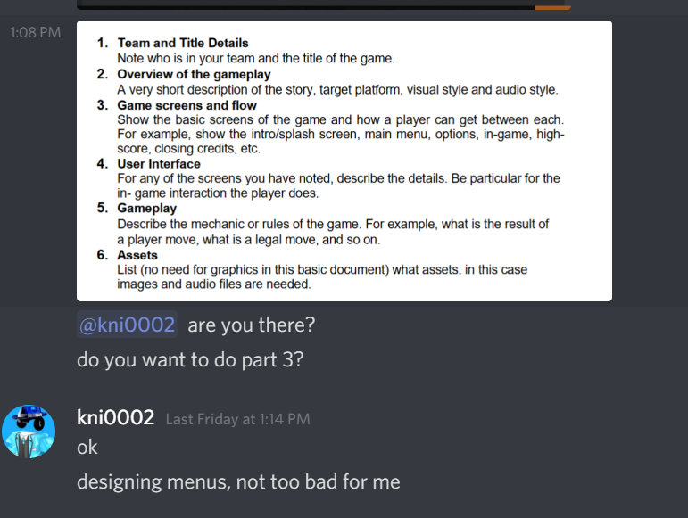

1. Then we use Disscord app which is created by Henry to voice chat and discuss about game details, gameplay, features, e.t.c . Every team member contributes their ideas, images.

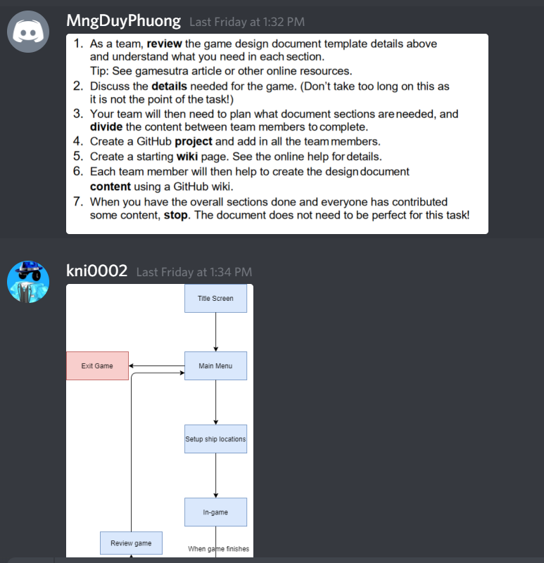

1. I edited the footer with our team basic information and the name of our project.

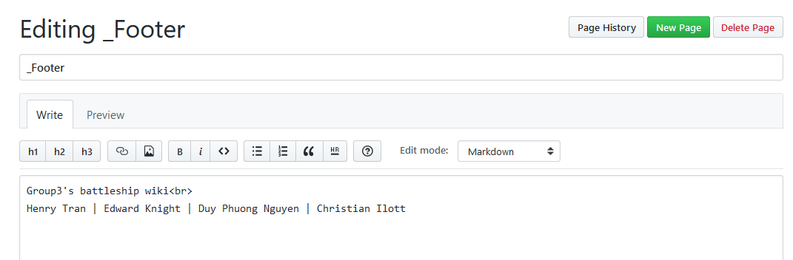

1. I completed the part 1 which is Team and title details

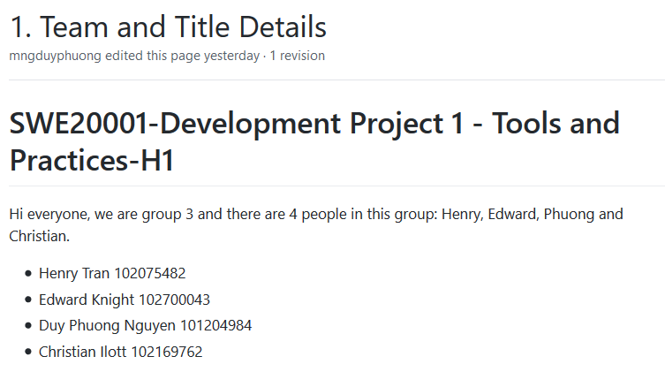

1. After waiting Edward to finish his part, I adding some information in “User Interface” page.

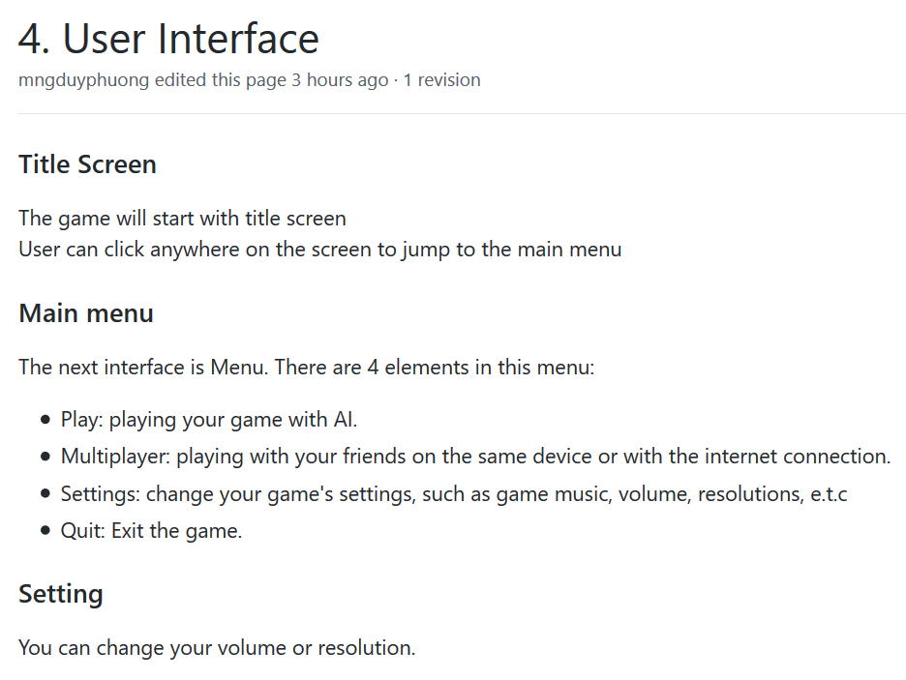

GitHub URL: <https://github.com/mngduyphuong/battleship-lab03/wiki>